Login Page:

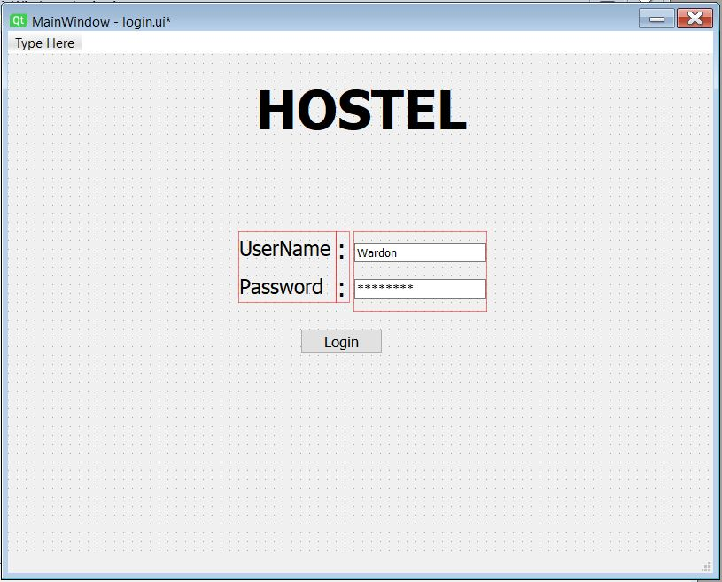

Choose one option and Click on “GO”

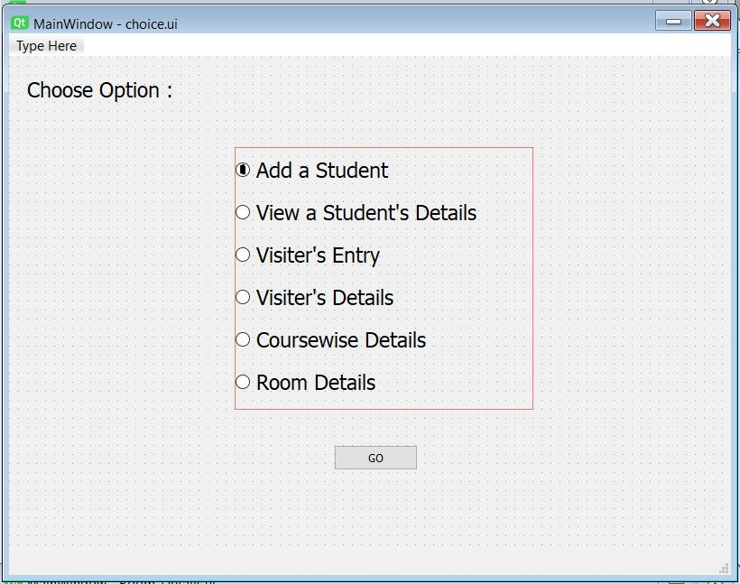

If you select “Add a Student”

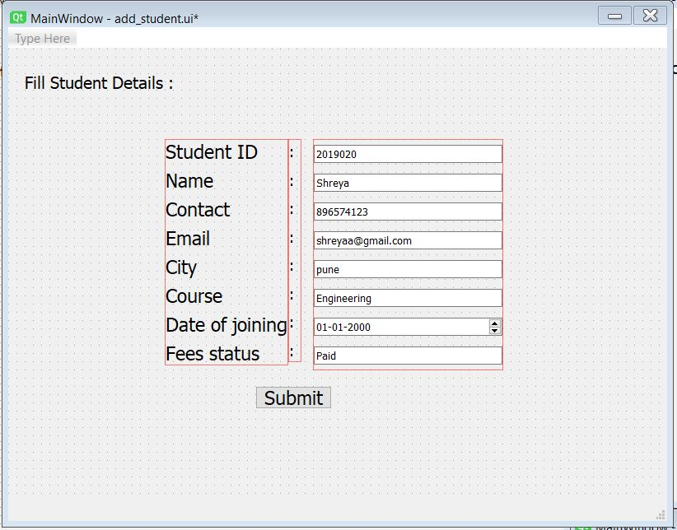

Then click on “Submit”

If you select “View a Student’s Details”

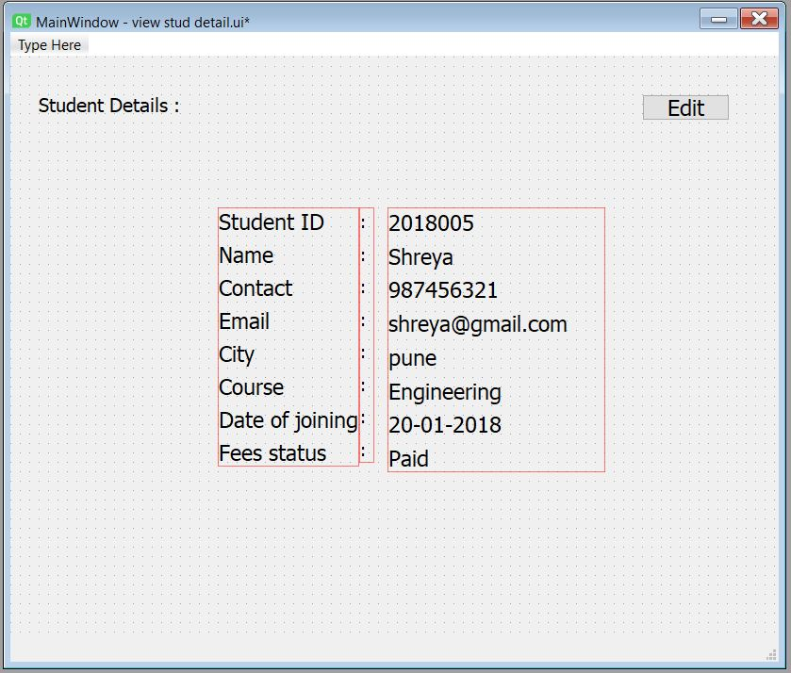

You can edit information by clicking on “Edit”

If you select “Visiter’s Entry”

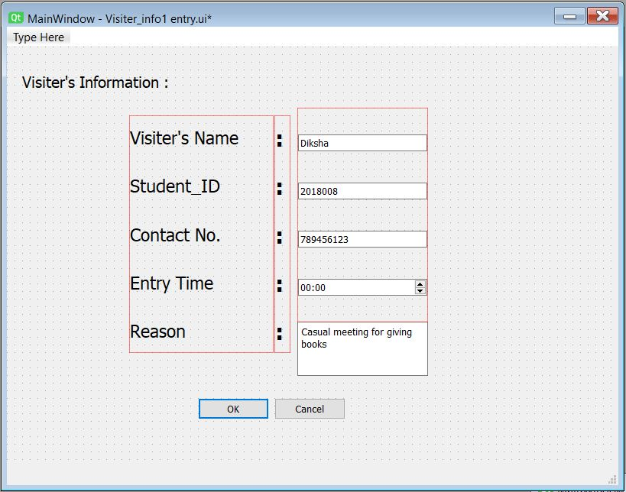

Then you can also add exit time on next

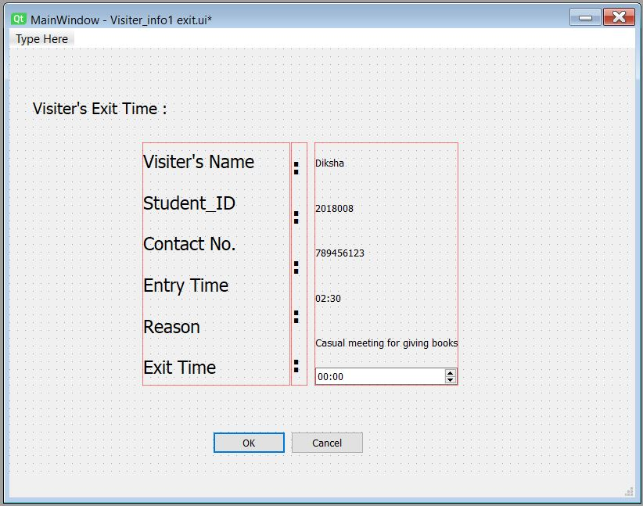

If you select “Room Details” it will display Details of student allocated in that room

